Power Management System

Project: |  | CORVETTE INDONESIA BN 397/398
Projectnumber: |  | 190134
Main title: |  | Power Management System
Sub title:
Special remark:
Issue: |  | 2.0
Date: |  | 22 August 2005
Total number of pages: |  | 22
Registration code:
 |  | Name |  | Signature
Author: |  | C. Schouten
Quality control: |  | A.W. Hartman
Acknowledge: |  | R. van Treuren
Approved: |  | Schelde Naval Shipbuilding
Certified:
Table of contents
Title page
Administrative page
Figures 0
Tables 0
Abbreviations 0
Updates 0
1. Introduction 0
1.1 Purpose of this document 0
1.2 Relationship to other documents 0
2. System overview 0
2.1 Introduction 0
2.2 Configuration of main electrical power generation plant 0
2.3 Power of main components 0
3. Power Management System 0
3.1 General 0
3.2 Interlocks 0
3.3 PMS functions 0
3.4 Operating modes of power management unit (Gensys) 0
3.4.1 Automatic mode 0
3.4.2 Semi automatic mode 0
3.4.3 Manual mode 0
3.5 Standby diesel generator set 0
3.6 Preference diesel generator set 0
3.7 Start and stop sequence with closed bus coupler circuit breakers 0
3.8 Start and stop sequence with open bus coupler circuit breakers 0
3.9 Assigning 1st standby 0
3.10 Load sharing 0
3.11 Black-out start 0
3.11.1 Full black-out start 0
3.11.2 Partial black-out start 0
3.12 Load depended start 0
3.13 Load depended stop 0
3.14 Running hours 0
3.15 Overload prevention 0
3.15.1 Tripping of non-essential consumers 0
3.15.2 Reducing the power of non-essential consumers 0
3.16 Safety system 0
3.17 Bus coupler circuit breakers 0
3.18 Shore circuit breaker 0
3.19 Emergency generator 0
Appendix A IO list PMS 0
Appendix B Parameter list PMS 0

Figures
Figure 1.1 Automation documentation structure, TNI-AL IAS 0
Figure 2.1 Block diagram of the Power Management System 0
Figure 2.2 Functional overview power distribution system 0
Figure 2.3 Power of main components 0
Figure 3.1 Lay-out of power management unit 0
Figure 3.2 Start and stop sequence diesel generator sets 0
Figure 3.3 Start/stop sequence after diesel generator sets 0
Figure 3.4 Start/stop sequence forward diesel generator sets 0
Figure 3.5 Generator load and start levels 0
Figure 3.6 Generator load and stop levels 0
Tables
Table 3.1 Parameter list PMS 0

References
 | Title: | Technical Specification
 | Description: | Technical Specification between Schelde Naval Shipbuilding and IMTECH Marine & Offshore
 | Ref.: | I 1005
 | From: | Schelde Naval Shipbuilding
 | Issue: | D
 | Date: | 23 September 2004
 | Title: | Documentation Plan
 | Description: | TNI-AL Documentation Plan
 | Ref.: | 190134-DCL-001
 | From: | R. v. Treuren
 | Issue: | 1.1
 | Date: | 31 January 2005
 | Title: | IAS System Specification
 | Description: | Overall System specification of the Integrated Automation System
 | Ref.: | 190134-4000-IAS-SSC
 | From: | E.J. Middeldorp
 | Issue: | V1.0
 | Date: | 9 May 2005
 | Title: | IPMS Functional Specification
 | Description: | Functional specification of the Integrated Platform Management System.
 | Ref.: | 190134-4380-FSC
 | From: | R. Langeveld
 | Issue: | V1.0
 | Date: | 9 May 2005
 | Title: | Power Conversion and Distribution – Electrical Plant General
 | Description: | Overview diagram power distribution (one-line diagram)
 | Ref.: | 190134-3000-GRS
 | From: | A.H. de Groot
 | Issue: | V2.2
 | Date: | 2 May 2005
 | Title: | IO List PMS
 | Description: | IO list PMS Gensys
 | Ref.: | 190134-3900-IOL
 | From: | C. Schouten
 | Issue: | V1.0
 | Date: | 5 August 2005
Abbreviations
DE Diesel Engine
DCU Diesel Control Unit
DG Diesel Generator
ESB Emergency Switchboard
FSC Functional Specification
GCB Generator circuit breaker
GCU Generator Control Unit
HMI Human Machine Interface
IMO Imtech Marine & Offshore
IPMS Integrated Monitoring & Control System
IO Input/Output
IPMS Integrated Platform Management System
LAN Local Area Network
LPU Local Processing Unit
MCR Machinery Control Room
ME Main Engine
MSB Main Switch Board
PCS Propulsion Control System
PMS Power Management System
SSC System Specification
TBD To Be Defined
Updates
Underneath are the updates indicated of those parts, which have been changed related to the previous release.

Issue: | Date: | Change: | Reason:
V2.0 | 22-08-2005 | Paragraph 3.18 Shore circuit breaker. | Export to other vessel added (RT-0042, act. no. 0001).

Introduction

Purpose of this document
This document contains the Power Management System (PMS) functional specification of the TNI-AL project for the Indonesia Navy Corvette program, Tentara Nasional Indonesia Angkatan Laut. This specification is based on the requirements as described in the references.

Relationship to other documents
This document is part of the system design documentation for the Integrated Automation System. It contains the overall design information for the PMS design.
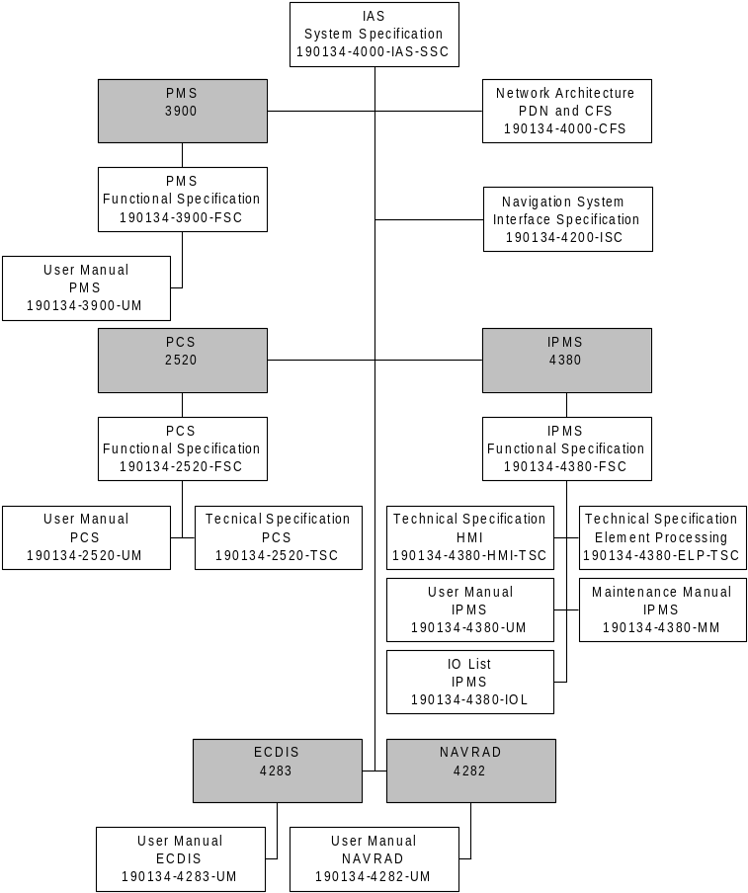

Figure 1.1 Automation documentation structure, TNI-AL IAS

System overview

Introduction
Power Management is a stand-alone system, integrated within the platform monitoring system dedicated for full automation of ships power plant and guarantees the availability of power in the most efficient way. The power management system is based on the GENSYS generator management system. The system for power distribution in this case consists of two (2) main switchboards (MSB’s) and each MSB is connected to two (2) diesel-generator sets, leads to four (4) diesel-generator sets in total for generating the ships power supply. Every diesel-generator set is equipped with it’s own GENSYS generator management module located on the MSB for optimum control of energy distribution aboard.

The power management system is integrated via MODBUS with the platform data network for communication with the HMI. The drawing below shows the communication between the GENSYS, LPU and HMI.

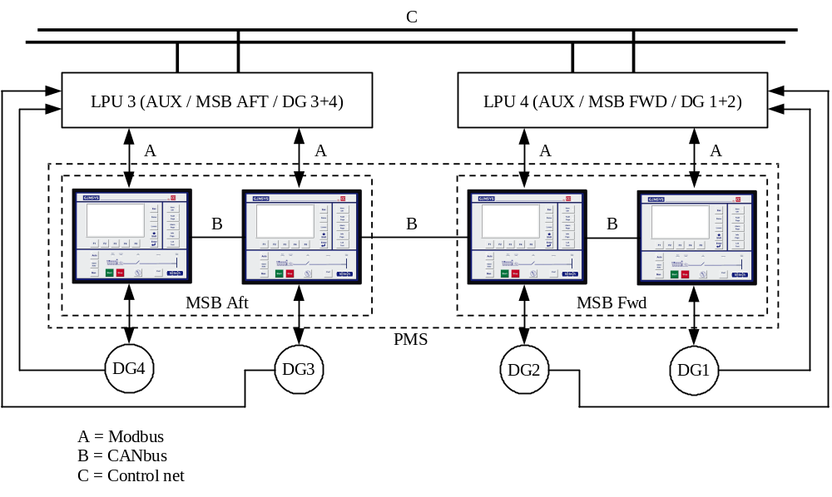
Figure 2.2 Block diagram of the Power Management System

Configuration of main electrical power generation plant
The electrical power generation plant consists of four (4) diesel engine driven generator sets, two (2) connected to each main switchboard and one (1) diesel engine driven emergency generator connected to the emergency switchboard. Two (2) bus couplers are fitted to connect/disconnect both main switchboards. Two (2) interconnection breakers, one (1) in each main switchboard, are fitted to connect/disconnect the emergency switchboard to one of the main switchboards.

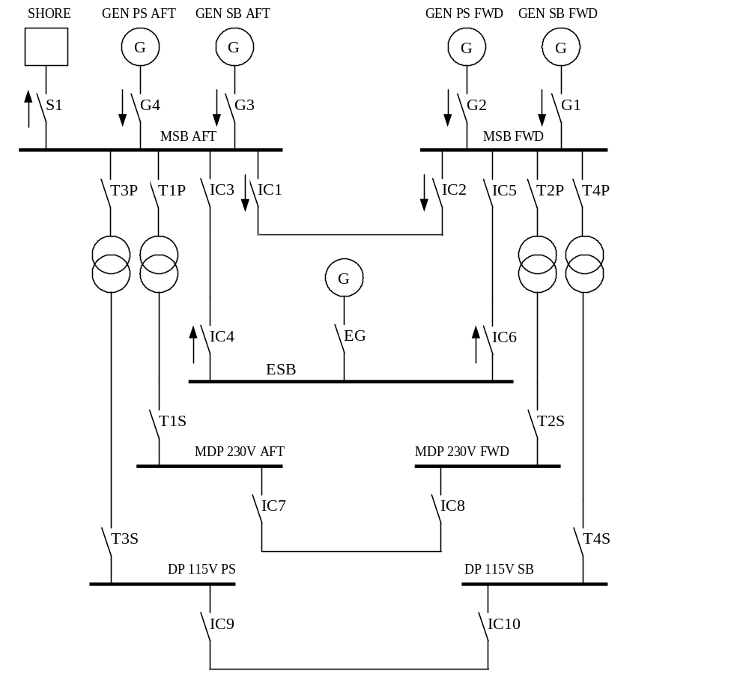

Figure 2.3 Functional overview power distribution system
Note: The arrows indicate the direction of synchronization.

For a detailed overview of the power distribution system see one-line diagram [5].

Power of main components
- Generator 320 kW
- Emergency generator 105 kW
- Chiller 108 kW
- Trafo 440/400-230V 100 kW
- Trafo 440/115V 64 kW
- Gun console 40 kW
- Sonar TXU 48 kW

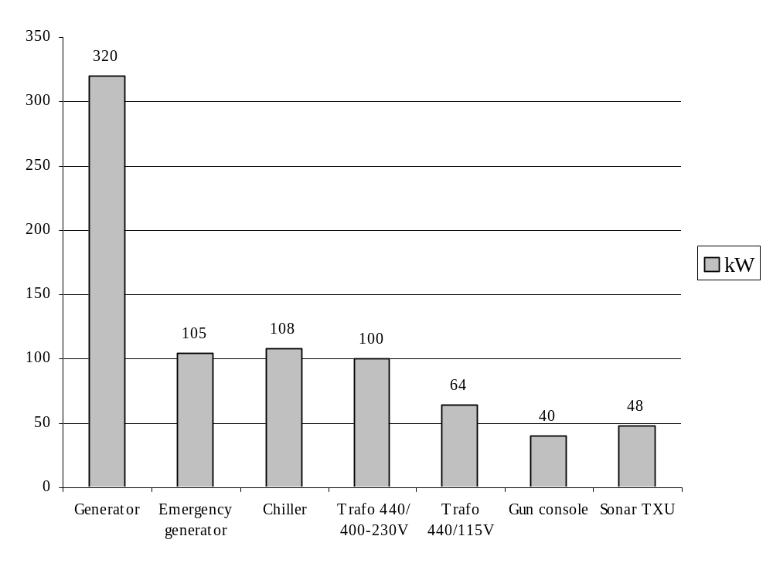
Figure 2.4 Power of main components

Power Management System

General
The PMS can control a diesel generator set only when the control unit in the local control panel of the diesel generator set is in STANDBY mode.

Each generator is protected against short-circuit and over current by an electronic protection unit inside the circuit breaker.

Interlocks
The following hardware interlocks are being made:
- Bus coupler circuit breakers IC1 and IC2 are interlocked during closing;
- Generator circuit breakers G3 and G4 are interlocked with IC1 during closing of IC1;
- Generator circuit breakers G1 and G2 are interlocked with IC2 during closing of IC2.

PMS functions
The power management system includes the following functions:
- Manual, semi-auto and auto mode selection;
- Load dependent automatic or manual starting and stopping of the generators;
- Loading and unloading the generators;
- Synchronising and load sharing of the generators;
- Synchronising the bus bars;
- Synchronising to shore;
- Protection of the generators (e.g. reverse power);
- Monitoring the power, current, voltage and frequency of generators;
- Activation of the automatic disconnection or reducing the power of non-essential consumers;
- Priority generator selection;
- Black-out monitoring/start.

Operating modes of power management unit (Gensys)
The power management units are installed in each generator section of the main switchboard. Each generator is equipped with its own and autonomous system.
The unit can be operated in automatic, semi automatic and manual mode. The manual mode can only be selected on the power management unit, the automatic and semi automatic mode can be selected on the power management unit as well as through IPMS.

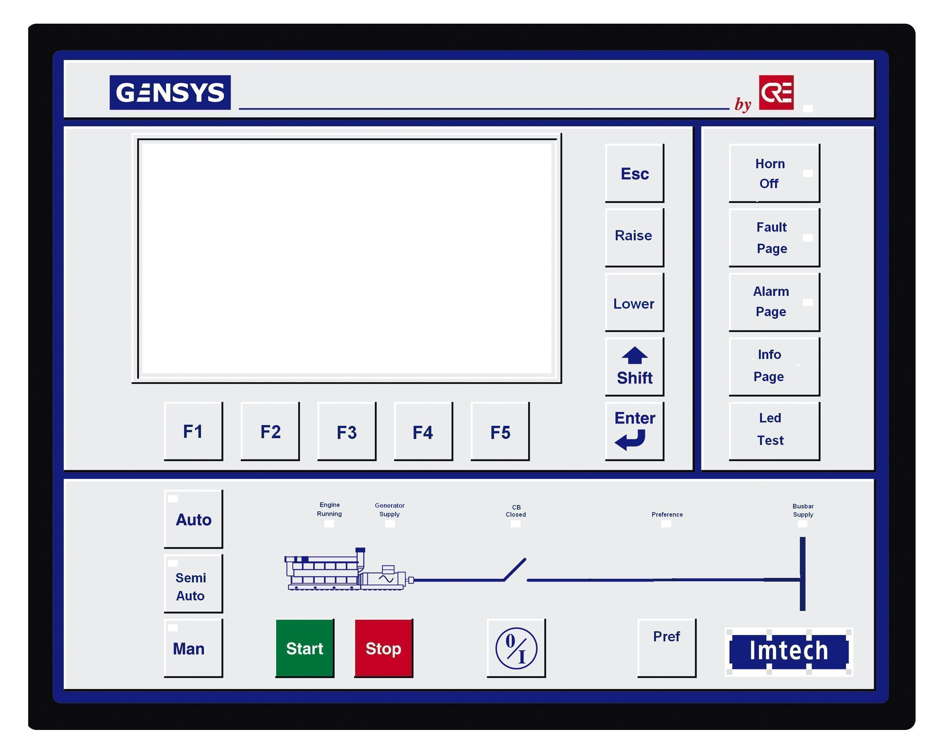
Figure 3.5 Lay-out of power management unit

Automatic mode
In automatic mode the following functions are available:
- Load dependent automatic start and stop of diesel generator sets;
- Automatic opening and closing of generator circuit breakers;
- Automatic synchronising of diesel generator sets;
- Automatic closing of bus coupler circuit breakers;
- Automatic loading and unloading the generators;
- Automatic load sharing;
- Non-essential consumers tripping and reducing;
- Black-out start;
- Automatic start on pre-alarm of running generator;
- Under- and over-voltage monitoring;
- Under- and over-frequency monitoring;
- Generator reverse power protection;
- Synchronising the bus bars;
- Synchronising to shore.

Semi automatic mode
In semi automatic mode the following functions are available:
- Manual start/stop by means of MSB pushbuttons or through the IPMS;
- Manual opening and closing of generator circuit breakers by means of pushbuttons on the power management unit or through IPMS;
- Automatic synchronising of diesel generator sets;
- Automatic loading and unloading the generators;
- Automatic load sharing;
- Non-essential consumers tripping and reducing;
- Under- and over-voltage monitoring;
- Under- and over-frequency monitoring;
- Generator reverse power protection;
- Synchronising the bus bars;
- Synchronising to shore.

Manual mode
In manual mode the following functions are available:
- Manual start/stop by means of the pushbuttons on the power management unit;
- Manual opening and closing of generator circuit breakers by means of pushbuttons on the power management unit;
- Manual opening and closing the bus coupler circuit breakers (IC1 and IC2) by means of pushbuttons on the MSB;
- Manual synchronising by means of the ‘LOWER’ and ‘RAISE’ pushbuttons on the power management unit;
- Manual load sharing by means of the ‘LOWER’ and ‘RAISE’ pushbuttons on the power management unit;
- Non-essential consumers tripping and reducing;
- Under- and over-voltage monitoring;
- Under- and over-frequency monitoring;
- Generator reverse power protection.

Standby diesel generator set
A diesel generator set which operating mode is set to ‘AUTO’, without any faults and not online or stopping is called ‘STANDBY’.

Preference diesel generator set
An online diesel generator set which operating mode is set to ‘AUTO’, without any faults can be selected as preference by means of the ‘Pref ’ pushbutton. A preference diesel generator set will always remain online, as long as there are no fault conditions for that set.
An offline diesel generator set which operating mode is set to ‘AUTO’ and which preference pushbutton is activated, will receive a start command and a circuit breaker ON request.
The start and stop sequence can be changed by changing the preference diesel generator.

Start and stop sequence with closed bus coupler circuit breakers
The start sequence of the diesel generator sets in case of closed bus coupler circuit breakers is determined by the set number of the preference diesel generator set and then going clock wise for 1st, 2nd and 3rd standby.

The first diesel generator set in the start/stop sequence is the preference diesel generator set. The second, third, etcetera diesel generator set in the start/stop sequence is called the 1st respectively the 2nd standby diesel generator set etc.

The stop sequence is the reverse order of the start sequence.

- The diesel generator sets not ‘STANDBY’ or ‘PREFERENCE’ will be excluded from the start/stop sequence.
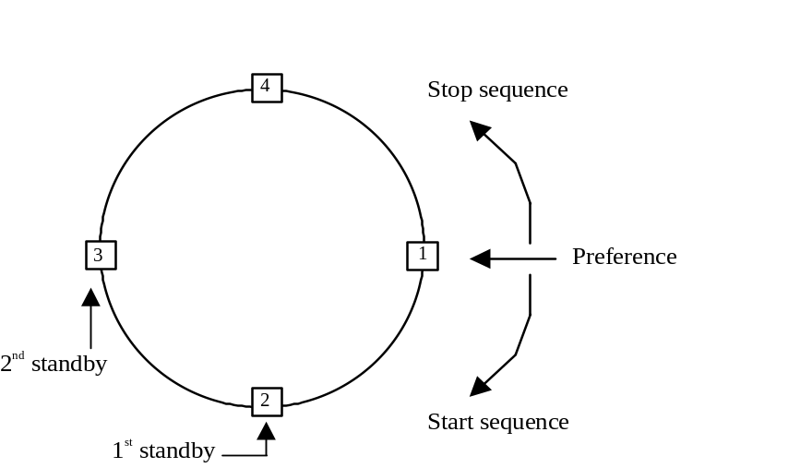
Figure 3.6 Start and stop sequence diesel generator sets
The numbers on the circle represent the diesel generator sets. Diesel generator set no. 1 is the preference generator, diesel generator set no. 2 is the 1st standby and diesel generator set 3 is the 2nd standby etc. So when there must start an extra diesel generator set due to extra load, diesel generator set no. 2 starts and diesel generator set no. 3 becomes the 1st standby.

Start and stop sequence with open bus coupler circuit breakers
Regarding the after diesel generator sets:
The start and stop sequence of these diesel generator sets is the same as mentioned in 3.7, except the forward diesel generators are excluded from the start/stop sequence.
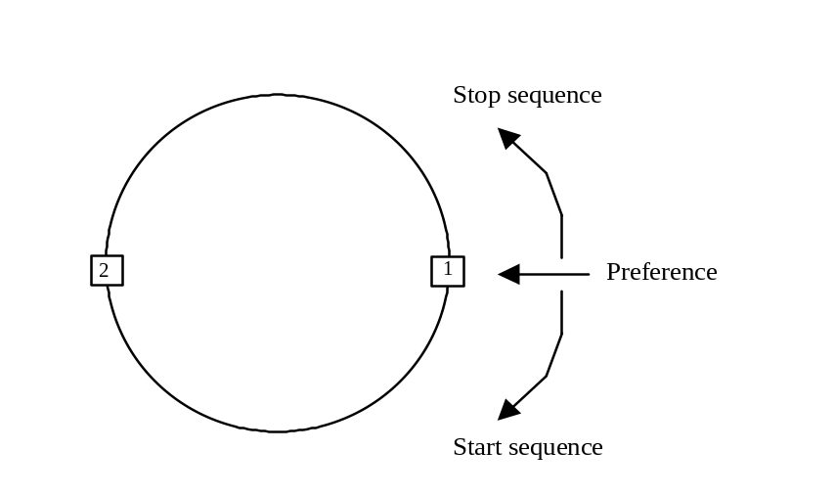

Figure 3.7 Start/stop sequence after diesel generator sets
Regarding the forward diesel generator sets:
The start and stop sequence of these diesel generator sets is the same as mentioned in 3.7, except the after diesel generators are excluded from the start/stop sequence.
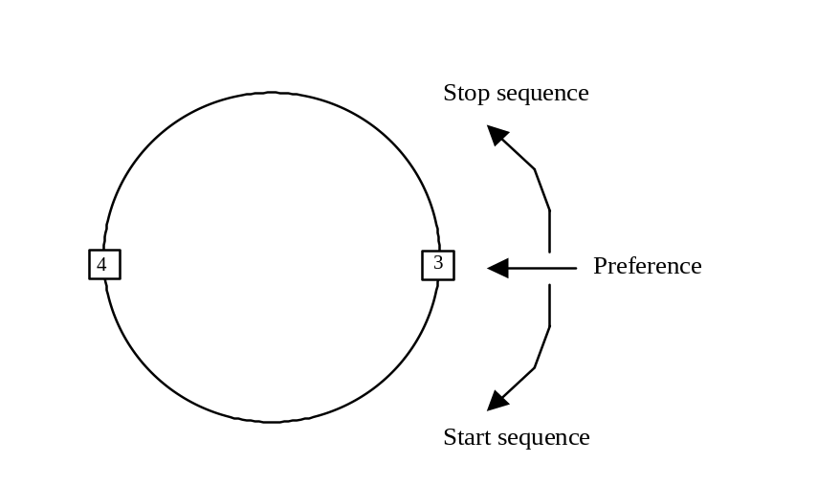

Figure 3.8 Start/stop sequence forward diesel generator sets

Assigning 1st standby
The ‘STANDBY’ diesel generator set directly following the preference set in the start/stop sequence (based on PMS unit number) is called the 1st standby.

If the 1st standby set can no longer be standby (due to a fault or change of operating mode) the next ‘STANDBY’ diesel generator set in the start sequence will automatically become 1st standby.

If the 1st standby set is required in order to meet the electrical demand, the next ‘STANDBY’ diesel generator set in the start sequence will automatically become 1st standby.
When this diesel generator set is not required anymore it will be stopped and becomes 1st standby again.

Load sharing
In automatic mode the load sharing takes place between generator sets connected to the same bus bar. This means:
- Load sharing between generator G1 and G2 and load sharing between generator G3 and G4 if bus coupler circuit breakers IC1 or IC2 are opened;
- Load sharing between generator G1, G2, G3 and G4 if bus coupler circuit breakers IC1 and IC2 are closed.

See also Figure 2.2, Block diagram of the Power Management System.

Black-out start

Full black-out start
In case of a black-out, no bus bar voltage detected (L1, L2 and L3 < 20% U nominal, all generator, both bus couplers and shore connection circuit breakers are open), all diesel generator sets in automatic mode will receive a start command and the accompanying generator circuit breaker an ON request. After a pre-defined period of time the superfluous diesel generator sets will be stopped, see paragraph 3.13.

For closing of the bus couplers see paragraph 3.17.

Partial black-out start
In case of a partial black-out, no bus bar voltage detected at one of the MSB’s (L1, L2 and L3 < 20% U nominal, all the circuit breakers of the concerning generators, bus coupler and if applicable the shore connection are open), all diesel generator sets in automatic mode of the MSB in question will receive a start command and the accompanying generator circuit breaker an ON request. After a period of time the superfluous diesel generator sets will be stopped, see paragraph 3.13.

For closing of the bus couplers see paragraph 3.17.

Load depended start
If the load of the connected diesel generator set(s) is higher then a pre-defined level during a pre-defined period of time, the 1st standby set will receive a start command and the generator circuit breaker an ON request and the load will be shared.
If the 1st standby set fails to start an alarm will be generated and the next ‘STANDBY’ diesel generator set in the start sequence will automatically receive a start command and the generator circuit breaker an ON request. The set following the starting diesel generator set will become the 1st standby.
This feature is only working in the automatic mode.

- 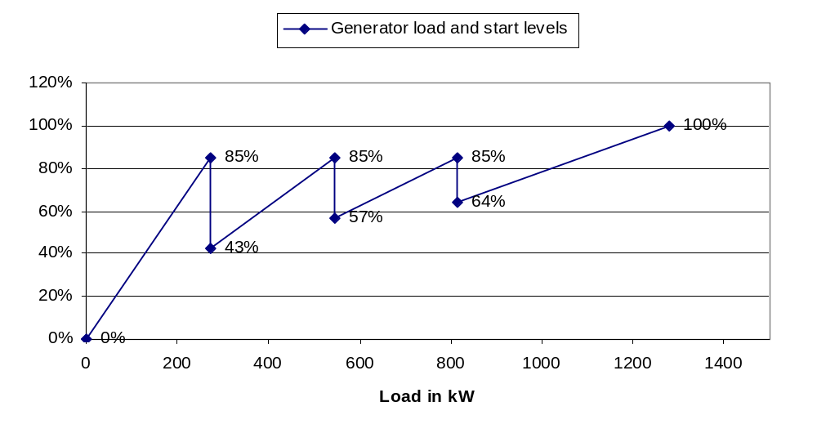
Figure 3.9 Generator load and start levels

Load depended stop
If the average load of the connected diesel generator sets (in automatic mode) is below a pre-defined level, depending of the number of diesel generator sets running, during a pre-defined period of time, the first diesel generator set in the stop sequence will take off load and will receive a circuit breaker OFF and a stop request (stop request after cooling down period). This process will go on until the last diesel generator set is running.

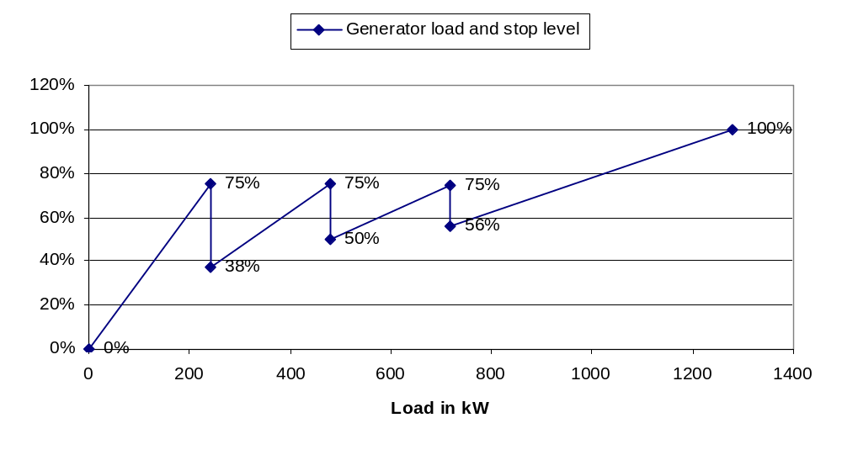
Figure 3.10 Generator load and stop levels

Running hours
- Each PMS module monitors the running hours of the diesel generator set.

Overload prevention
To prevent overload of a running diesel generator, tripping and reducing the power of non-essential consumers will be used to limit the total load.

Tripping and reducing the power of the non-essential consumers will be done in two stages. The non-essential consumers will be tripped or reduced in case of overload (kW or A) or under-frequency.
- First stage: Generator actual load is ≥ 100% during 5 seconds or the frequency is < 58 Hz during 5 seconds.
- Second stage: Generator actual load is ≥ 110% during 1 second or the frequency is < 55 Hz during 1 second.

The system remains active until the reset is activated and the conditions for tripping and reducing are not valid anymore.

Note: The non-essential tripping and reducing system is also active after a black out.

Tripping of non-essential consumers
The following non-essential consumers will be tripped:
- Distribution panel 440V laundry;
- Distribution panel 440V galley;
- Hot water boiler 300 liters.

The tripped feeders of the non-essential consumers can be switched on manually after resetting the system.

Note: The non-essential feeders will also trip at a black out.

Reducing the power of non-essential consumers
The following non-essential consumers will be reduced:
- AC chiller unit 1;
- AC chiller unit 2.

Safety system
The diesel engines have their own independent protection system. The PMS receives a shutdown signal from the diesel engines safety system in case of:
- Low-low lub oil pressure;
- High-high cooling water temperature HT;
- Engine overspeed;
- Emergency stop.

- The PMS will trip the generator breaker and stop the DG set in case of:
- Diesel engine safety system (shutdown system) is active;
- Reverse power;
- Low-low / high-high frequency;
- Low-low / high-high voltage.

The PMS will automatic start the 1st standby diesel on a pre-alarm of a running diesel generator. The set with the pre-alarm will stop when the 1st standby diesel generator is on-line.

A diesel generator pre-alarm is generated in case of:
- High generator winding temperature (via IPMS to PMS);
- Diesel generator common alarm (via IPMS to PMS).

A diesel generator common alarm consist of the following signals:
- Low lub oil pressure;
- High lub oil temperature;
- High cooling water temperature;
- Low cooling water level;
- Fuel oil leakage;
- Fuel/water separator level;
- Speed sensor failure;
- Low supply voltage DCU panel DG.

When there is one generator running and no standby generators available the PMS will send an alarm to the IPMS.

Bus coupler circuit breakers
Both bus coupler circuit breakers (IC1 and IC2) are in normal circumstances closed. The bus coupler circuit breaker will receive an ON request after the bus bar voltage is available for a pre-defined period of time (adjustable at the MSB) and the operation mode of the bus coupler circuit breakers is automatic. To prevent closing at the same time, the bus coupler circuit breakers are interlocked (see paragraph 3.2).

Shore circuit breaker
Import from shore or other vessel:
The shore circuit breaker will receive an ON request if the operation mode of the shore circuit breaker is automatic and the pushbutton ‘CB CLOSE’ is activated. If the operation mode of the power management unit is automatic, the running generator will synchronise to the frequency of the shore. The generator circuit breaker opens automatically after the shore circuit breaker is closed. The shore circuit breaker opens automatically (if operating mode is automatic) after the first diesel generator set is running in parallel with the shore.

Export to other vessel:
Export to an other vessel is possible only when the operation mode of the shore circuit breaker is set to manual and a generator is running. The shore circuit breaker will close after the pushbutton ‘CB CLOSE’ is activated.

Emergency generator
The emergency generator is not a part of the PMS. If a blackout occurs (the interconnection breakers to the MSB will open) and the emergency generator mode is selected, the emergency generator will start after a pre-defined period of time (adjustable at the ESB) and the emergency generator circuit breaker will close. Continuous parallel operation with the MSB is not possible, but a bump less take over is possible in manual or automatic operation. Synchronizing is only possible over the selected interconnection breaker at the ESB. In manual mode the operator has to synchronize the emergency generator frequency to the frequency of the MSB, by means of the raise or lower speed pushbuttons on the ESB.
The emergency generator circuit breaker opens automatically after the interconnection breaker is closed. The emergency generator will stop automatically after a cooling down period.
Appendix A IO list PMS
See document ‘190134-3900-IOL’ (File ‘190134-3900-IOL-1-NR10.xls’)
Appendix B Parameter list PMS

Description | Value | Time delay | Remarks
Frequency non-essential stage 2 | -8% | 1s | Non-essential trip
Frequency low-low | -5% | 10s | Trip
Frequency non-essential stage 1 | -3.5% | 5s | Non-essential trip
Frequency low | -3% | 10s | Alarm
Frequency high | 3% | 10s | Alarm
Frequency high-high | 5% | 10s | Trip
Voltage low-low | -7% | 10s | Trip
Voltage low | -5% | 10s | Alarm
Voltage high | 5% | 10s | Alarm
Voltage high-high | 7% | 10s | Trip
Reverse power | -8% | 15s | Trip
Power non-essential stage 1 | 100% | 5s | Non-essential trip
Power non-essential stage 2 | 110% | 1s | Non-essential trip
Winding temperature high | 140ºC | 5s | Alarm
Load dependent start level | 85% | 10s | Start level 1st standby
Load dependent stop level 1 | 38% | 5min
Load dependent stop level 2 | 50% | 5min
Load dependent stop level 3 | 56% | 5min
Closing delay bus coupler CB |  | 40s
Start delay EM generator |  | 10s
Winding temperature high | 140ºC | 5s | Alarm
Table 3.1 Parameter list PMS

